**Name :**

**Hafsa Waseem**

**Roll no:**

**SU92-BSSEM-S24-014**

**Subject :**

**DSA (Lab)**

**Section :**

**3A**

**Submitted to:**

**Sir Rasikh**

**Task no 11:**

**Queue with linked list and array tasks .**

* **With Array ;**

**Enqueue ,Dequeue , display**

* **With Linkedlist;**

**Enqueue ,Dequeue , display**

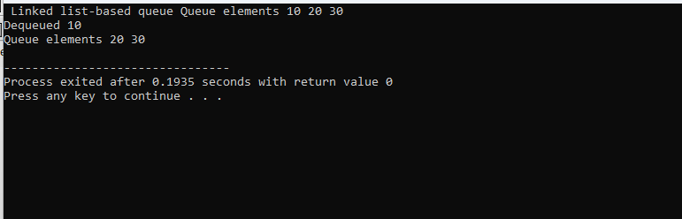

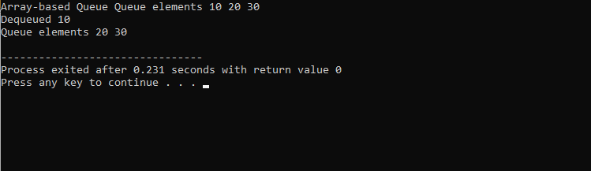

**Explain :**

This code shows two ways to make a queue: one with an array and one with a linked list. In the array queue, we use a fixed size array and two positions called front and rear. We add items at the back and remove them from the front. If the array is full, we cannot add more items. If it is empty, we can not remove anything. In the linked list queue, we use small blocks called nodes that are linked together. Each node holds a number and points to the next one. We can add new nodes at the end and remove them from the front. This queue can grow or shrink, so it does not have a size limit. Both types do the same work, just in different ways.